Daylight Saving Time (DST)

Definition:
# Source: AI Source: Provided by: [Data Path: Persons Table -> ID Column: 1, Name_En Column: Motasem Essam] -> From: [ChatGPT] on [1/26/2026]
Daylight Saving Time (DST) is the practice of moving the clocks forward by one hour during the warmer months to extend evening daylight, and then moving them back by one hour in colder months.

Key Points
# Source: AI Source: Provided by: [Data Path: Persons Table -> ID Column: 1, Name_En Column: Motasem Essam] -> From: [ChatGPT] on [1/26/2026]
- Purpose: To make better use of daylight and save energy.
- Start and End: Varies by country.
  - Usually starts in spring (spring forward)
  - Ends in autumn/fall (fall back)
- Effect on Time Zones: Temporarily shifts the UTC offset.
- Not used worldwide: Some countries, especially near the equator, do not observe DST.

Example
# Source: AI Source: Provided by: [Data Path: Persons Table -> ID Column: 1, Name_En Column: Motasem Essam] -> From: [ChatGPT] on [1/26/2026]
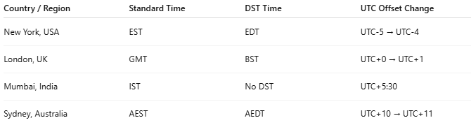
Country / Region | Standard Time | DST Time | UTC Offset Change
New York, USA | EST | EDT | UTC-5 → UTC-4
London, UK | GMT | BST | UTC+0 → UTC+1
Mumbai, India | IST | No DST | UTC+5:30
Sydney, Australia | AEST | AEDT | UTC+10 → UTC+11

How DST Works
# Source: AI Source: Provided by: [Data Path: Persons Table -> ID Column: 1, Name_En Column: Motasem Essam] -> From: [ChatGPT] on [1/26/2026]
- Spring: Clocks move forward 1 hour → lose 1 hour of sleep
- Fall: Clocks move back 1 hour → gain 1 hour of sleep

Analogy
# Source: AI Source: Provided by: [Data Path: Persons Table -> ID Column: 1, Name_En Column: Motasem Essam] -> From: [ChatGPT] on [1/26/2026]
- Think of DST as shifting your daily schedule to get more daylight in the evening.
- Like starting work earlier in summer to enjoy longer daylight after work.

Advantages
# Source: AI Source: Provided by: [Data Path: Persons Table -> ID Column: 1, Name_En Column: Motasem Essam] -> From: [ChatGPT] on [1/26/2026]
- Saves electricity (less need for artificial lighting)
- Encourages outdoor activities in the evening
- Reduces traffic accidents in evening hours (more daylight)

Disadvantages
# Source: AI Source: Provided by: [Data Path: Persons Table -> ID Column: 1, Name_En Column: Motasem Essam] -> From: [ChatGPT] on [1/26/2026]
- Disrupts sleep and biological clock
- Can cause confusion in international scheduling
- Minimal energy saving in modern times

✅ Summary
# Source: AI Source: Provided by: [Data Path: Persons Table -> ID Column: 1, Name_En Column: Motasem Essam] -> From: [ChatGPT] on [1/26/2026]
- DST = adjusting clocks forward in spring, back in fall
- Purpose = maximize daylight usage
- Affects time zones temporarily

